Real-Time Temperature Prediction Technique of Aluminium Electrolysis Furnace Based on the KSI Principle
[Author names and affiliations to be inserted]
Corresponding author: [email]
Contents
Abstract
1 Introduction
2 Related Work and Motivation
2.1 Physics-based and numerical modeling
2.2 Data-driven machine-learning approaches
2.3 Fuzzy approximate reasoning and fuzzy modeling
2.4 Research gap and contributions
3 A New Fuzzy Modeling Method Based on the Moving Rate
4 Temperature Prediction Model and Verification
5 Discussion
6 Conclusion
References

Abstract
This paper develops a real-time temperature-prediction technique for aluminium electrolysis furnaces based on the moving-rate form of uncertainty reasoning, referred to as the KSI principle. The method embeds KSI reasoning into a dynamic Takagi-Sugeno (T-S) fuzzy model: s-type, z-type, and trapezoidal antecedent sets are converted into moving rates; rule influence is obtained by moving-rate product reasoning; and consequent parameters are updated recursively from streaming input-output data. This construction is designed to preserve the interpretability of rule-based models while avoiding the max-min compositional reasoning used in conventional fuzzy inference and the multi-epoch training burden typical of ANFIS. The study further corrects the dimensionally inconsistent conclusion-parameter update reproduced in an earlier product-reasoning formulation and provides a consistent recursive least-squares update for online identification. The method is implemented with voltage and current as continuously available inputs and a single thermocouple used for calibration/verification. Tests on 60 industrial aluminium electrolysis furnaces report model accuracy above 99%; for furnace No. 2, the reported accuracy is 99.86% with a mean error of 0.315 °C, compared with 99.76% and 2.289 °C for the ANFIS baseline using 25 rules rather than five. The paper also benchmarks the proposed method against earlier furnace predictors and recent machine-learning and ANFIS literature, emphasizing algorithmic complexity, online adaptation, sensor burden, interpretability, and cross-study limitations. The results support the KSI-based T-S model as a compact and computationally practical soft sensor for real-time furnace-temperature prediction.
Keywords: fuzzy reasoning; temperature prediction; prediction model; moving rate; KSI principle; T-S fuzzy model; aluminium electrolysis furnace

1 Introduction
The bath temperature of an aluminium electrolysis furnace directly reflects the energy balance of the cell and is one of the most important process variables for stable and energy-efficient aluminium production: it governs current efficiency, ledge formation, anode effects, and the service life of the cell lining. Keeping the electrolyte temperature within its narrow optimal operating window is therefore critical, yet the temperature is conventionally measured by thermocouple only at long intervals (about every three hours in practice), because continuous immersion measurement in the corrosive cryolite melt is impractical and costly. A reliable real-time prediction of the furnace temperature from easily measured electrical signals (cell voltage and line current) is consequently of great industrial value.
Terminology and physical meaning of the cell. In this paper, the word cell denotes one aluminium reduction cell (also called an electrolytic pot or, in plant terminology, an electrolysis furnace) in a Hall-Heroult potline; it does not mean a battery cell or a biological cell. A reduction cell is a refractory-lined steel vessel containing the cryolite-based molten electrolyte and a molten aluminium layer, with carbon anodes above and a carbon cathode lining below. The large direct current passing through the bath supplies the electrochemical reaction and a substantial part of the process heat. Consequently, cell voltage and line current carry indirect information about heat generation, bath resistance, feed/anode events, and the thermal balance. The bath temperature therefore summarizes the instantaneous thermal condition of the cell, while slow changes in ledge thickness, bath composition, anode state, and lining condition cause the input-output relationship to drift over time. This physical interpretation is why a recursively adaptive but interpretable nonlinear model is attractive for real-time soft sensing.
The 2025-2026 literature reinforces this motivation. Lin et al. [17] showed that LightGBM can predict the bath temperature of a 500-kA cell with an average difference of 1.6 °C using a rich set of production features. Recent work has also used machine learning to accelerate prediction of aluminium-cell temperature fields and side-ledge morphology [36], three-dimensional electro-thermal finite-difference modeling for digital manufacturing [37], machine-learning prediction of cryolitic-bath liquidus temperature [38], and improved CNN-LSTM temperature-field prediction [39]. These studies demonstrate rapid progress toward digital twins and high-fidelity thermal models, but they also sharpen the practical niche addressed here: a low-dimensional, online-updatable, rule-based predictor that can operate with only easily measured electrical signals and sparse thermocouple supervision.
An adaptive identification algorithm based on a regressive model was introduced to solve the real-time temperature prediction problem [1]. However, such a regressive model, which represents the characteristic of the aluminium electrolysis furnace with a single analytic expression, is not appropriate for representing the strong nonlinearity of the object and has low accuracy. To solve this problem, many works have been devoted to representing the nonlinearity of objects effectively, ranging from computational-fluid-dynamics simulation [4] and real-time thermal prediction in enclosures [3] to data-driven machine learning [10-18] and fuzzy reasoning and modeling [2, 5-7, 19-30].
In [4], a new fuzzy modeling method based on superalloy heating in a resistance electrolysis furnace was introduced and the effectiveness of the method was verified. However, it is impossible to use the fuzzy modeling method of [4] for the estimation of conclusion parameters. Otherwise, unlike [4], in [5] a new fuzzy reasoning method based on a compensating operation, the so-called moving rate, was proposed and applied to fuzzy neural network systems. Based on [5], in [6] the authors presented a fuzzy reasoning method based on a distance measure and discussed its reductive property, and in [7] a new fuzzy modus ponens and modus tollens based on moving distance in the SISO fuzzy system was proposed.
In [8, 9], a fuzzy identification algorithm for temperature prediction of the aluminium electrolysis furnace was proposed and a prediction was made for the temperature of the aluminium electrolysis furnace for three hours. The accuracy of the prediction is not high, and the approach is expensive because it uses three sensors for one aluminium electrolysis furnace.
In this paper, we present a new method for real-time temperature prediction of aluminium electrolysis furnaces by applying fuzzy reasoning based on the moving rate of uncertainty reasoning proposed in [5-7] (which we call the KSI principle) to the fuzzy model identification problem. In other words, our method is based on the moving rate of uncertainty reasoning. We then compare our method with previous methods through simulation experiments and real tests in the field.
The main contributions of this paper are summarized as follows. First, building on the moving-distance and reductive-property line of research [24, 25] and, in particular, the interval fuzzy modeling extension of the KSI principle in [26], we transfer KSI reasoning from SISO approximate reasoning to online MISO dynamic T-S identification for a real industrial thermal process. Moving rates are defined for s-type, z-type, and trapezoidal antecedent membership functions, so rule activation is computed directly from the displacement of the current input relative to each fuzzy set. Second, unlike the application-oriented fuzzy/FCM developments in [27, 28], the present work couples KSI activation with recursive estimation of the T-S consequent parameters; therefore, the model can be updated sample by sample rather than rebuilt offline. Third, the resulting rule path is directly traceable from input -> moving rate -> normalized rule weight -> local linear consequent -> predicted temperature, complementing the explainability objective pursued by the causal-entropic fuzzy framework in [29] without requiring a separate post-hoc explanation layer. Fourth, the method corrects the dimension inconsistency in the conclusion-parameter update reproduced from the classical product-reasoning formulation used as the baseline in this manuscript and explicitly distinguishes that correction from the validity of the broader Takagi-Sugeno model class. Fifth, the approach is verified on 60 industrial furnaces using one thermocouple per furnace for calibration/verification and continuously measured voltage/current, and is compared with ANFIS, the earlier patents [8, 9], the KSI-related literature [24-29], and recent data-driven temperature predictors. These contributions jointly position the work as a KSI-based online system-identification method rather than only another static fuzzy predictor.
The remainder of this paper is organized as follows. Section 2 reviews related work on temperature prediction of aluminium electrolysis furnaces and on fuzzy approximate reasoning, and states the research gap. Section 3 describes the new fuzzy modeling method based on the moving rate. Section 4 presents the temperature prediction model of the aluminium electrolysis furnace and its experimental verification. Section 5 discusses the results, and Section 6 concludes the paper.

2 Related Work and Motivation
Research on modeling and prediction for the aluminium electrolysis process has been active for five decades; a recent bibliometric analysis of the field from 1970 to 2023 documents a marked acceleration of intelligent, data-driven studies in the last few years [16]. Existing approaches can be grouped into three families: physics-based numerical models, data-driven machine-learning models, and knowledge-based fuzzy models.

2.1 Physics-based and numerical modeling
First-principles approaches describe the thermal state of the cell by heat- and mass-balance equations. Moazamigoodarzi et al. developed real-time temperature predictions in IT server enclosures using reduced thermal models [3], showing that physically grounded models can run in real time when the geometry is simple. For high-temperature metallurgical objects, Fu et al. proposed a new modeling method for superalloy heating in a resistance electrolysis furnace using FLUENT-based computational fluid dynamics [4]. Such models provide valuable physical insight, but for an industrial aluminium electrolysis cell they require detailed knowledge of geometry, material properties, and boundary conditions, demand heavy computation that conflicts with real-time use, and cannot easily adapt online when the cell condition drifts (ledge profile change, anode replacement, lining ageing). Moreover, as noted above, the conclusion-parameter estimation required for adaptive prediction cannot be carried out within the framework of [4].

2.2 Data-driven machine-learning approaches
With the accumulation of production data, machine learning has been widely applied to the aluminium electrolysis process. Zhou et al. predicted anode effects with a singular-value-thresholding and extreme-gradient-boosting approach [10]; Lu et al. predicted the liquidus temperature of complex electrolyte systems by machine-learning methods [11]; Cao et al. proposed an online prediction method for the molten aluminium height based on a kernel extreme learning machine [12]; and Chen et al. carried out time-series prediction of iron and silicon content in the metal [13]. For temperature itself, Lei et al. designed a self-supervised deep LSTM network for industrial temperature prediction in aluminium processes [14], and Zhu et al. combined a dual-attention LSTM for the non-stationary sub-sequence with an ARMA model for the stationary sub-sequences to predict the cell temperature, alleviating the low accuracy and hysteresis of earlier soft sensors [15]. Lundby et al. modeled the coupled mass and energy balance of the cell with sparse neural networks with skip connections, which outperformed plain multilayer perceptrons especially for long prediction horizons and limited data [18]. Most recently, Lin et al. predicted the bath temperature of a 500-kA reduction cell with five machine-learning models and found that LightGBM performs best, reaching an average difference of 1.6 °C between predicted and measured temperature, with SHAP analysis used to interpret the model [17].
These studies confirm the strong nonlinearity of the temperature dynamics and the feasibility of data-driven prediction. Nevertheless, deep and ensemble models share several practical drawbacks for furnace-side deployment: they need large historical data sets and periodic offline retraining; their many parameters make online recursive adaptation difficult; their black-box character limits acceptance by operators (which is precisely why post-hoc explanation tools such as SHAP had to be added in [17]); and per-cell customization of a potline with hundreds of cells is costly. This motivates transparent rule-based models whose parameters can be updated recursively in real time.

2.2.1 Key temperature-prediction baselines used in Section 5
Reference [2] represents the classical fuzzy-modeling/fuzzy-control baseline used by this manuscript. Its value is structural transparency: a nonlinear plant is represented by local fuzzy rules and local consequents. However, the version discussed here relies on conventional matching/composition and interval updating; the supplied manuscript reports that its furnace-temperature accuracy did not reach 91%. Reference [14] replaces explicit fuzzy rules with a self-supervised deep LSTM soft sensor. It is designed for limited labeled pot-temperature data and learns long temporal dependencies, but training is GPU/epoch based and the internal state is less interpretable than a five-rule T-S model. Reference [15] further decomposes the temperature series by wavelet analysis, sends the non-stationary component to a dual-attention LSTM, models stationary components by ARMA, and recombines the sub-predictions. This addresses hysteresis and mixed time-scale information at the cost of a substantially more complex offline pipeline. Reference [17] evaluates SVR, KRR, RF, GBDT and LightGBM on a 500-kA cell; LightGBM is best and achieves an average predicted-versus-measured difference of 1.6 °C, while SHAP is required to explain feature importance. Reference [18] uses sparse neural networks with skip connections to improve long-horizon open-loop stability and accuracy under limited training data, again trading direct rule-level explanation for nonlinear approximation power. These five baselines are revisited quantitatively and algorithmically in Section 5.
English interpretation of references [8] and [9]. Reference [8], originally cited as a Chinese invention patent, is rendered in English in this manuscript as 'Fault predictor for aluminium electrolysis.' Its function is a furnace/pot fault-prediction scheme rather than the present continuous KSI temperature soft sensor. Reference [9], a Chinese utility-model patent, is rendered as 'On-site measuring device for the primary-crystal (liquidus) temperature of aluminium electrolyte.' It focuses on obtaining the liquidus/primary-crystal temperature through dedicated measuring hardware. Thus, [8] and [9] are important industrial precedents but differ fundamentally from the present work: they are patent/device-oriented solutions, whereas the proposed method is an online mathematical soft sensor that estimates bath temperature continuously from routine electrical signals and needs only sparse thermocouple measurements for identification and verification.

2.3 Fuzzy approximate reasoning and fuzzy modeling
Fuzzy set theory offers exactly such transparency. Since Zadeh introduced the concept of the linguistic variable and its application to approximate reasoning [1], the compositional rule of inference (CRI) and the T-S fuzzy model have become standard tools of fuzzy modeling and fuzzy control [2]. However, CRI-type reasoning does not, in general, satisfy the reductive property, and the classical T-S identification based on product reasoning contains a contradiction in its fourth estimation stage [1, 6], so that many refinements of the inference mechanism have been studied.
One active line of research replaces composition by distance- or similarity-based inference. Luo and Wang studied interval-valued fuzzy reasoning full-implication algorithms based on t-representable t-norms [19]; Duan and Li analysed similarity measures of intuitionistic fuzzy sets and their applications [21]; and Liu and Li proposed quintuple intuitionistic fuzzy implication reasoning algorithms [22]. Fuzzy rule interpolation, which infers conclusions for sparse rule bases from the distances between fuzzy sets, has also progressed rapidly: Li et al. demonstrated interpretable mammographic mass classification with fuzzy interpolative reasoning [20], and Xu et al. advanced dynamic fuzzy rule interpolation via density-based spatial clustering of interpolated outcomes [23]. These recent studies confirm that distance-driven inference remains a central topic of approximate reasoning.
Our group has developed a coherent alternative stream based on the moving rate (compensating operation). A fuzzy reasoning method based on the compensating operation and its application to fuzzy systems was proposed in [5]; a fuzzy reasoning method based on a distance measure with a proven reductive property was presented in [6]; fuzzy modus ponens and modus tollens based on moving distance in the SISO fuzzy system were established in [7]; an extended-distance-measure reasoning method for discrete fuzzy set vectors of different dimensions was reported in [24]; and an approximate reasoning method based on the least common multiple with its property analysis was given in [25]. Collectively we refer to this reasoning principle - rule activation computed from the moving rate of the input with respect to the antecedent fuzzy sets - as the KSI principle. The principle has recently been extended to interval fuzzy modeling and applied to turf color image evaluation [26], to precipitation forecasting and disaster warning [28], and to agricultural parameter selection [27]. In parallel, explainability and tuning of fuzzy systems continue to develop, e.g., through causal-entropic Bayesian frameworks for robust fuzzy inference [29] and improved shark smell optimization with adaptive parameter scheduling for fuzzy controller tuning [30].
For the aluminium electrolysis furnace in particular, fuzzy identification predictors were patented in [8, 9], but their model accuracy is only about 85% and three temperature sensors per furnace are required, while the interval-measurement updating scheme of [2] did not reach 91% accuracy.

2.3.1 Recent ANFIS models and relation to the proposed KSI architecture
ANFIS remains one of the closest comparators because it also combines fuzzy rules with a Sugeno-type consequent model. Four recent studies clarify both its strengths and its differences from Figure 1. Feced-Mas et al. [31] proposed a 2026 knowledge-driven ANFIS for thermal-system control and reported transparent rule tracing with tight temperature regulation; the method is a controller designed from thermodynamic knowledge rather than an online aluminium-cell predictor. Donkor et al. [32] used a hybrid Mamdani-ANFIS architecture for an industrial heating furnace; their Sugeno ANFIS used five Gaussian membership functions per input, 25 fuzzy rules and 100 training epochs, demonstrating strong control and energy-saving performance but still relying on a training phase. Azma and Liu [33] coupled CFD with ANFIS to predict temperature distributions rapidly on refined meshes, showing how ANFIS can act as a surrogate for an expensive physical solver. Khasawneh et al. [34] used ANFIS regression for thermal properties and showed that multicollinearity and outliers materially affect the learned model. Robust ANFIS learning has likewise been studied with alternative loss functions to reduce outlier sensitivity [35].
Relative to these ANFIS architectures, Figure 1 of the present paper has a simpler online path: voltage/current -> KSI moving-rate evaluation -> product rule activation -> normalized rule weights -> recursive T-S consequent update -> temperature. The proposed model does not backpropagate through antecedent membership parameters at every update, and it does not require a multi-epoch retraining cycle. In the reported furnace No. 2 experiment, it uses five rules versus 25 for ANFIS. The trade-off is that ANFIS can learn both antecedent and consequent shapes and may therefore be more flexible when abundant representative training data are available. The proposed KSI model instead prioritizes reductive reasoning, compact rule structure, deterministic online updates, and operator traceability.

2.3.2 2025-2026 advances in aluminium-cell thermal modeling
Very recent studies broaden the comparison space beyond scalar bath-temperature prediction. Chen et al. [36] combined high-fidelity MHD-CFD data with decision tree, random forest, XGBoost, KNN and SVR surrogates for rapid temperature-field and side-ledge prediction; the best random-forest surrogate reduced a reported 168 h CFD computation to about 3 min while preserving strong temperature-field agreement. Novozhilov et al. [37] developed a three-dimensional coupled electro-thermal finite-difference model of an aluminium reduction cell, highlighting the value of physically resolved thermal fields but also the computational and parameterization burden of first-principles simulation. Betsis et al. [38] compared MLR, MLP and SVR for cryolitic-bath liquidus temperature and obtained approximately 1.5 °C RMSE for the black-box models on their main dataset, while also showing a loss of extrapolation performance outside the training composition range. Li et al. [39] proposed an improved CNN-LSTM method for aluminium-cell temperature-field prediction. Together with [17], these studies indicate that 2025-2026 research is moving toward high-dimensional, data-rich and digital-twin-oriented prediction. The present KSI model addresses a complementary requirement: inexpensive per-cell deployment, online recursive adaptation and rule-level interpretability under sparse temperature measurements.

2.4 Research gap and contributions
The above review reveals a clear gap. Physics-based models [3, 4] are accurate in principle but computationally heavy and not adaptive online. Machine-learning models [10-18] achieve good accuracy but require large data sets and lack the transparency and cheap recursive adaptation demanded by potline operation. Classical fuzzy identification [1, 2] is transparent but suffers from the contradiction of its estimation stage and from low accuracy when a single global expression is used, and the existing furnace-specific fuzzy predictors [8, 9] are both inaccurate and sensor-expensive. Finally, our previous moving-rate reasoning methods [5-7, 24, 25] were formulated for the SISO case and had not yet been connected to recursive T-S parameter identification for a real industrial MISO object. The present paper closes this gap by building a moving-rate-based (KSI-principle) T-S modeling method with consistent recursive least-squares identification and by validating it on 60 industrial aluminium electrolysis furnaces with a single thermocouple sensor per furnace.

3 A New Fuzzy Modeling Method Based on the Moving Rate

3.1 KSI moving-rate reasoning embedded in a dynamic T-S model
Unlike Zadeh’s max-min composition principle [1], the new fuzzy modeling method based on the moving rate [5-7] is as follows.
The key modeling decision is to separate the problem into two layers. The first layer is the KSI reasoning layer, which converts the geometric displacement between the current input and each antecedent fuzzy set into a moving rate. The second layer is the dynamic T-S identification layer, which treats the normalized KSI rule activations as known regressors and estimates the local linear consequent parameters recursively. This separation is important: KSI changes how a rule is activated, while the T-S consequent preserves a transparent local input-output relationship. For R rules and d regressor components, the online reasoning cost for moving-rate evaluation and normalization is O(Rd). If recursive least squares is used for P=R(d+1) consequent parameters, the parameter update is O(P^2) per labeled sample and memory is O(P^2). No backpropagation epoch is required for online adaptation.
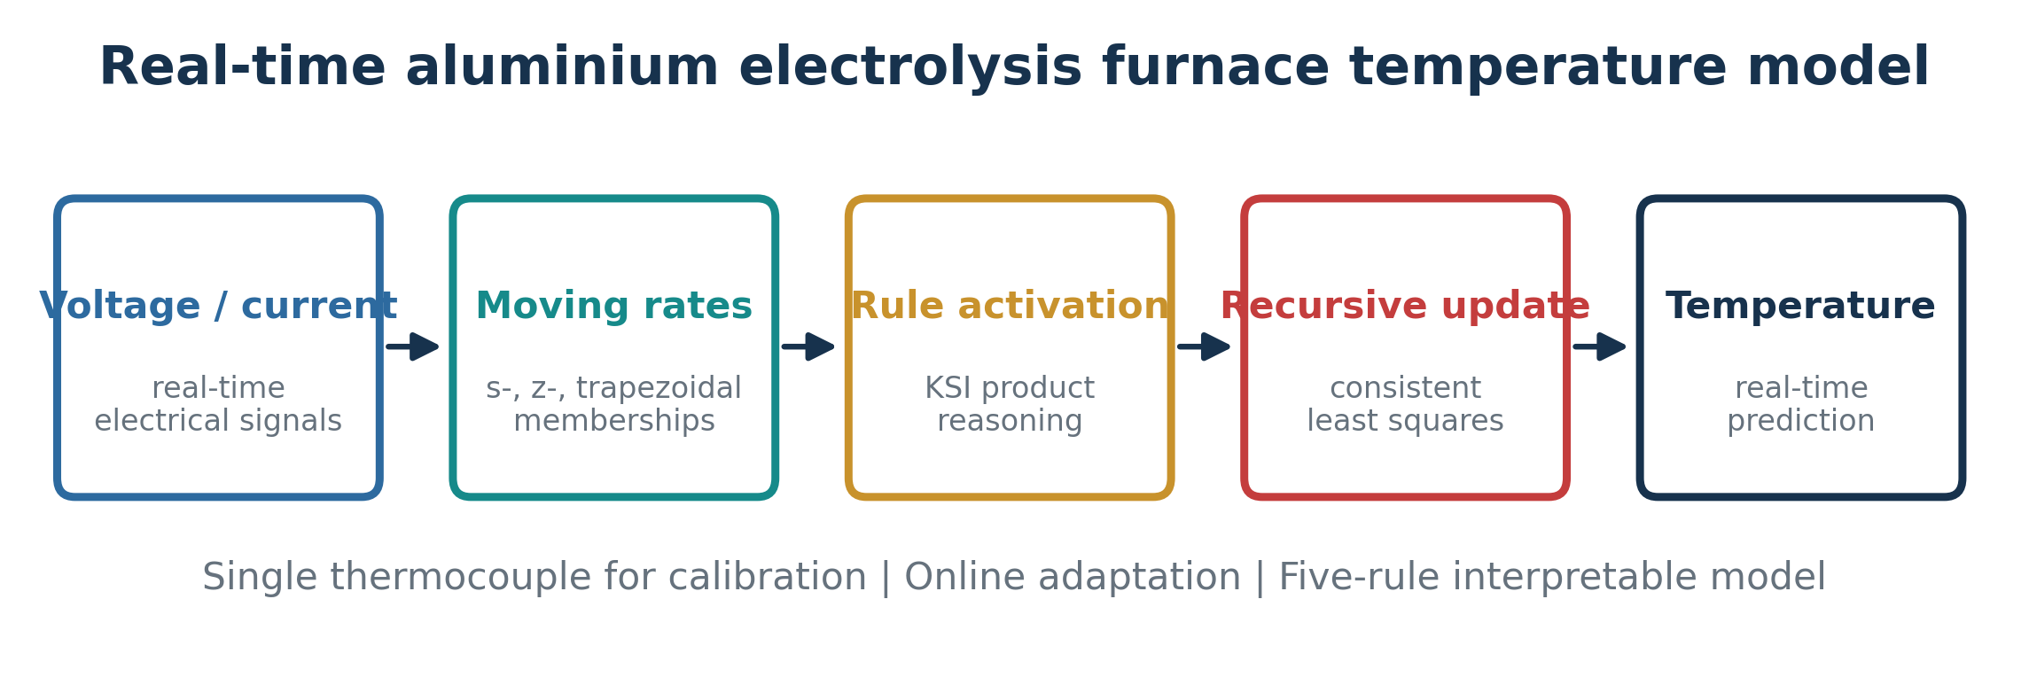
Figure 1. End-to-end workflow of the proposed KSI-principle temperature-prediction model.
The moving rates for s-type, z-type, and trapezoidal membership functions are defined as follows. For input information $x_{j}^{0}$, the moving rates $d_{ij}$ of rule $i$ and input $j$ are defined by formulas (1), (2), and (3), respectively.
For the s-type membership function with breakpoints $x_{aij}<x_{cij}$,
$$d_{ij}=\left\{\begin{matrix}\frac{x_{cij}−x_{j}^{0}}{x_{cij}−x_{aij}}, & x_{aij}≤x_{j}^{0}<x_{cij}, \\ 0, & x_{j}^{0}≥x_{cij}, \\ 1, & x_{j}^{0}<x_{aij}.\end{matrix}\right. \text{(1)}$$
For the z-type membership function with breakpoints $x_{aij}<x_{cij}$,
$$d_{ij}=\left\{\begin{matrix}0, & x_{j}^{0}≤x_{aij}, \\ \frac{x_{j}^{0}−x_{aij}}{x_{cij}−x_{aij}}, & x_{aij}<x_{j}^{0}≤x_{cij}, \\ 1, & x_{j}^{0}>x_{cij}.\end{matrix}\right. \text{(2)}$$
For the trapezoidal membership function with breakpoints $x_{1ij}<x_{2ij}<x_{3ij}<x_{4ij}$,
$$d_{ij}=\left\{\begin{matrix}1, & x_{j}^{0}<x_{1ij}\text{ or }x_{j}^{0}≥x_{4ij}, \\ \frac{x_{2ij}−x_{j}^{0}}{x_{2ij}−x_{1ij}}, & x_{1ij}≤x_{j}^{0}≤x_{2ij}, \\ 0, & x_{2ij}≤x_{j}^{0}≤x_{3ij}, \\ \frac{x_{j}^{0}−x_{3ij}}{x_{4ij}−x_{3ij}}, & x_{3ij}≤x_{j}^{0}≤x_{4ij}.\end{matrix}\right. \text{(3)}$$
The recursive matrix construction procedure of the T-S fuzzy model, which is based on product reasoning, is as follows.
Stage 1. For input information $x_{j}^{0}$, obtain the moving rates $d_{ij}$ using formulas (1)-(3).
Stage 2. Obtain the product term $d_{i}$ of each rule using formula (4):
$$d_{i}=1−\left[d_{i1}∧d_{i2}∧⋯∧d_{im}\right], i=1,…,n. \text{(4)}$$
Stage 3. Calculate the normalized rate ${\hat{d}}_{i}$ of each rule affecting the output:
$${\hat{d}}_{i}=\frac{d_{i}}{\sum_{q=1}^{n}{d_{q}}}. \text{(5)}$$
Stage 4. The fuzzy model output $y^{0}$, calculated by formula (6), determines the recursive matrix $Z$ using formula (7):
$$y^{0}=\sum_{i=1}^{n}{{\hat{d}}_{i}}y^{i}=\sum_{i=1}^{n}{\left(a_{i0}z_{0}^{i}+a_{i1}z_{1}^{i}+⋯+a_{im}z_{m}^{i}\right)}. \text{(6)}$$
$$Z=\left[\begin{matrix}z_{0}^{1\left(1\right)} & z_{1}^{1\left(1\right)} & ⋯ & z_{m}^{n\left(1\right)} \\ z_{0}^{1\left(2\right)} & z_{1}^{1\left(2\right)} & ⋯ & z_{m}^{n\left(2\right)} \\ z_{0}^{1\left(p\right)} & z_{1}^{1\left(p\right)} & ⋯ & z_{m}^{n\left(p\right)}\end{matrix}\right]. \text{(7)}$$
The fuzzy modeling method based on the moving rates proceeds with T-S fuzzy modeling using input-output data as follows. Denote the coefficients of formula (6) with a vector
$$A={\left[a_{10} a_{11} ⋯ a_{1m} a_{20} ⋯ a_{nm}\right]}^{T}. \text{(8)}$$
The T-S fuzzy model rule is
$$R^{i}: \text{if }x_{1}\text{ is }A_{i1},…,x_{m}\text{ is }A_{im},\text{ then }y^{i}=a_{i0}+\sum_{j=1}^{m}{a_{ij}}x_{j}. \text{(9)}$$
Here, $R^{i}$ ($i=1,…,n$) is the $i$th object rule, $x^{0}={\left[x_{1}^{0},x_{2}^{0},…,x_{m}^{0}\right]}^{T}$ is the input vector, $A_{ij}$ is the $j$th antecedent fuzzy set of the $i$th rule, and $y^{i}$ is the conclusion value of $R^{i}$. By fuzzy reasoning, the set $y={\left[y_{1},y_{2},…,y_{p}\right]}^{T}$ of $p$ real output values may be expressed as
$$y=ZA+ε. \text{(10)}$$
Here, $p$ is the number of input-output data couples and $ε={\left(ε_{1},ε_{2},…,ε_{p}\right)}^{T}$ is the corresponding error vector, with
$$z_{j}^{i\left(k\right)}=\left\{\begin{matrix}{\hat{d}}_{i}, & j=0, \\ {\hat{d}}_{i}x_{j}^{0\left(k\right)}, & j=1,…,m,\end{matrix}\right. i=1,…,n, k=1,…,p. \text{(11)}$$
Here, $x_{j}^{0\left(k\right)}$ is the $j$th element of the $k$th input vector, $n$ is the number of rules, and $m$ is the dimension of the input information. Construct the recursive matrix by using the fourth stage of product reasoning. The estimation formulas proposed in reference [1] contradict each other, and it is impossible to use its conclusion-parameter estimation. Because $θ_{k}$ in formula (12) is a row vector and $F_{k}\left(y_{k}−H_{k}θ_{k−1}\right)$ is a column vector, matrix addition is impossible there. The corrected recursive estimation is
$$θ_{k}=θ_{k−1}+F_{k}\left(y_{k}−H_{k}θ_{k−1}\right). \text{(12)}$$
$$F_{k}=\frac{S_{k−1}H_{k}^{T}}{1+H_{k}S_{k−1}H_{k}^{T}}. \text{(13)}$$
$$S_{k}=S_{k−1}−F_{k}H_{k}S_{k−1}. \text{(14)}$$
Here, $θ_{k}$ is the parameter vector to estimate, $S_{k}$ is the standard-deviation matrix, and $H_{k}$ is the data vector defined by formula (15):
$$H_{k}=\left[W_{k}^{1},W_{k}^{1}x_{1k},…,W_{k}^{1}x_{mk},W_{k}^{2},W_{k}^{2}x_{1k},…,W_{k}^{n},W_{k}^{n}x_{mk}\right]. \text{(15)}$$
The results that investigate the conclusion-parameter estimation formula of reference [1] and obtain the new estimation formula are as follows. For the dynamic T-S fuzzy system represented by formula (16), the conclusion-parameter vector is estimated by formula (17):
$$R^{i}: \text{if }ξ\left(k\right)\text{ is }A_{i}, \text{then} y^{i}\left(k\right)=a_{i0}+\sum_{j=1}^{n_{1}}{a_{ij}}y\left(k−j\right)+\sum_{r=1}^{p}{\sum_{ℓ=0}^{n_{r}}{b_{irℓ}}}u_{r}\left(k−t_{dr}−ℓ\right). \text{(16)}$$
$$θ_{k}=θ_{k−1}+F_{k}\left(y_{k}−H_{k}θ_{k−1}\right), S_{k}=S_{k−1}−F_{k}H_{k}S_{k−1}, F_{k}=\frac{S_{k−1}H_{k}^{T}}{1+H_{k}S_{k−1}H_{k}^{T}}. \text{(17)}$$
Here, $R^{i}$ is the $i$th fuzzy rule; $ξ\left(k\right)$ is the dynamic regressor containing the lagged outputs and delayed inputs; $A_{i}$ is its antecedent fuzzy region; $y^{i}$ is the conclusion reasoning output value; $a_{ij}$ and $b_{irℓ}$ are conclusion parameters; $u_{1}\left(⋅\right),…,u_{p}\left(⋅\right)$ are input variables; $y\left(⋅\right)$ is the output variable; $k$ is the time variable; and $t_{d1},…,t_{dp}$ are the input time delays.

3.2 Pseudocode of the proposed KSI-T-S modeling method
Pseudocode 1. Proposed KSI-T-S online modeling and identification.
Algorithm 1. Online KSI-based dynamic T-S identification
Input: stream {(x_k, y_k)}, R rules, antecedent sets A[r,j], forgetting factor lambda, theta_0, P_0
for each sampling instant k:
form dynamic regressor z_k from current voltage/current and selected lags
for each rule r = 1..R:
for each antecedent variable j = 1..d:
m[r,j] <- moving_rate(z_k[j], A[r,j]) using Eq. (1)-(3)
beta[r] <- product_j m[r,j] # KSI product activation
w[r] <- beta[r] / (sum_s beta[s] + eps) # normalized rule influence
phi_k <- concatenate_r( w[r] * [1, z_k]^T ) # T-S regression vector
y_hat_k <- phi_k^T theta_{k-1}
if measured temperature y_k is available:
e_k <- y_k - y_hat_k
K_k <- P_{k-1} phi_k / (lambda + phi_k^T P_{k-1} phi_k)
theta_k <- theta_{k-1} + K_k e_k
P_k <- (P_{k-1} - K_k phi_k^T P_{k-1}) / lambda
else:
theta_k <- theta_{k-1}; P_k <- P_{k-1}
output y_hat_k and store rule weights w[1..R] for traceability
return theta, predictions, errors, and rule-weight history

3.3 Comparison with conventional Takagi-Sugeno fuzzy modeling
The proposed method remains a T-S model in its consequent structure; the novelty is not a rejection of Takagi-Sugeno modeling but a replacement of the conventional antecedent matching/inference step by KSI moving-rate reasoning plus a consistent online estimation arrangement. This distinction should be explicit because the dimensional inconsistency discussed around Eqs. (12)-(15) concerns the particular recursive formula reproduced from the baseline formulation used in this manuscript, not the entire T-S literature. A conventional T-S model normally computes firing strengths directly from membership grades and a t-norm/product, normalizes them, and forms a weighted sum of local linear consequents. The KSI model instead computes a moving quantity first and uses it as the rule-effect measure. Both can use RLS once the regression vector has been constructed; hence their asymptotic RLS complexity can be similar, while their reasoning semantics and constant computational cost differ.
Pseudocode 2. Conventional T-S inference used as the structural baseline.
Algorithm 2. Conventional T-S product-reasoning baseline
Input: x_k, R fuzzy rules with membership functions mu_A[r,j], consequent parameters theta
for each rule r = 1..R:
alpha[r] <- product_j mu_A[r,j](x_k[j])
w[r] <- alpha[r] / (sum_s alpha[s] + eps)
for each rule r:
f_r <- a[r,0] + sum_j a[r,j] x_k[j]
y_hat_k <- sum_r w[r] f_r
if online identification is enabled:
construct the standard T-S regression vector and update theta with a dimensionally consistent RLS rule
return y_hat_k
Table 2. Detailed comparison of conventional T-S modeling and the proposed KSI-based T-S method.
Aspect | Conventional T-S fuzzy model | Proposed KSI-based T-S model
Antecedent activation | Membership grade mu_A(x) and t-norm/product | Moving rate derived from displacement relative to s-, z-, or trapezoidal set
Reasoning principle | Conventional fuzzy matching / product reasoning | KSI compensating/moving-rate reasoning [5-7,24-26]
Reductive-property emphasis | Not guaranteed by generic CRI; depends on inference design | Explicit design objective inherited from KSI reasoning
Consequent | Local linear/affine Sugeno function | Same transparent local linear/affine T-S consequent
Online parameter update | Possible with RLS or other estimators | Recursive least squares integrated with KSI-generated normalized weights
Antecedent adaptation | Fixed or separately optimized | Fixed interpretable sets in present implementation; future interval/type-2 extension follows [26]
Per-sample reasoning cost | O(Rd) before parameter update | O(Rd) before parameter update
RLS cost | O(P^2) for P consequent parameters | O(P^2); P=R(d+1) for a static first-order consequent, adjusted for dynamic regressors
Interpretation | Rule firing = degree of membership match | Rule firing = normalized moving/compensating effect
Main practical distinction | Classical fuzzy matching semantics | KSI semantics + compact five-rule online furnace model

3.4 Comparison with ANFIS and recent neuro-fuzzy thermal models
Figure 1 and ANFIS share a Sugeno-type rule-output philosophy but differ in how model structure is obtained. ANFIS is usually a five-layer adaptive network: fuzzification, rule firing, normalization, consequent evaluation and output summation. Its hybrid training adjusts antecedent membership parameters by gradient/backpropagation and consequent parameters by least squares over repeated epochs. This flexibility is powerful, especially for complex thermal systems [31-35], but the rule count can grow rapidly under grid partitioning and training must be repeated when the operating distribution changes. The proposed architecture fixes a compact interpretable antecedent partition, computes rule influence from KSI moving rates, and updates the consequent recursively whenever a new temperature label becomes available. Thus, it trades some structural flexibility for lower retraining burden and direct online traceability.
Table 3. Recent ANFIS studies versus the proposed KSI-T-S model.
Reference / method | Task | Core algorithm | Training / update | Reported evidence | Difference from proposed Figure 1
[31] Feced-Mas et al., 2026 | Thermal-system control | Knowledge-driven ANFIS | Design-based; no historical-data dependence emphasized | ±0.2 °C stable regulation; robust under disturbances | Controller, not aluminium-cell soft sensor; ANFIS rule network rather than KSI moving rates
[32] Donkor et al., 2026 | Industrial heating-furnace control | Hybrid Mamdani -> Sugeno ANFIS | 25 rules, hybrid LS/backpropagation, 100 epochs | ~30% energy saving; faster disturbance response | Requires training phase and 25-rule ANFIS; proposed furnace model uses 5 KSI-T-S rules
[33] Azma & Liu, 2026 | Temperature-field surrogate | CFD + ANFIS | Train ANFIS on CFD nodes | R^2 about 1 for selected setup; ~17x mesh-density increase | Spatial surrogate learned from CFD, not recursive plant identification
[34] Khasawneh et al., 2025 | Thermal-property regression | FCM/ANFIS regression | Offline data cleaning + ANFIS training | RMSE and R^2 improve strongly after outlier handling | Highlights data-conditioning sensitivity absent from deterministic KSI activation
[35] Nik-Khorasani et al., 2024 | General ANFIS regression | Robust hybrid learning | Robust loss + hybrid ANFIS training | Improved robustness to noise/outliers | Optimizes ANFIS learning objective; proposed method avoids iterative antecedent training
This paper | Aluminium bath-temperature prediction | KSI moving rate + dynamic T-S + RLS | Single-pass recursive update from sparse thermocouple labels | No.2: 99.86%; mean error 0.315 °C; 5 rules | Compact online soft sensor; rule effect defined by KSI principle

4 Temperature Prediction Model of the Aluminium Electrolysis Furnace and Its Verification
The industrial implementation is organized into three stages: synchronized data acquisition, KSI-T-S model construction/online identification, and independent verification/deployment. The separation is deliberate because temperature labels are sparse while electrical inputs are continuously available. A prediction can therefore be produced at every process sampling instant, but the recursive parameter vector is corrected only when a trustworthy thermocouple measurement arrives.

4.1 Stage 1 - Data acquisition, synchronization, and cell-wise data preparation
- Stage 1 acquires the information needed to identify one model for one reduction cell. Cell voltage and line current are read from the plant data server at the normal process sampling rate. Bath temperature is measured with the thermocouple at the available manual/periodic measurement instant and is treated as the supervisory output label. Records are time-stamped, aligned to the same cell identifier, screened for missing or impossible values, and stored in a cell-wise database. Dynamic regressors are then built from the current electrical variables and the chosen delayed samples. Importantly, the term cell always refers to one aluminium reduction pot; models are not mixed across cells unless an explicit transfer-learning experiment is performed.

4.2 Stage 2 - KSI-T-S model construction and recursive prediction/update
- Stage 2 initializes the five-rule fuzzy partition and the consequent-parameter covariance, then runs Algorithm 1 on the synchronized stream. At each time step, the s-, z-, and trapezoidal antecedent sets generate KSI moving rates; these are multiplied and normalized to obtain the rule effects. The resulting rule weights form the T-S regression vector. A temperature prediction is available immediately. When the thermocouple temperature for that cell is present, the prediction residual drives the RLS correction; when it is absent, the last identified parameters are retained and only prediction is performed. This event-driven update is what makes the model suitable for the long interval between physical temperature measurements.
Pseudocode 3. Detailed Stage 1-Stage 3 modeling and verification procedure.
Algorithm 3. Three-stage aluminium-cell temperature modeling procedure
Input: plant database, cell IDs C, electrical streams V(t), I(t), sparse measured temperatures T(t)
for each cell c in C:
# Stage 1: data preparation
synchronize V_c, I_c, T_c by timestamp; remove invalid records; construct lagged regressor z_k
# Stage 2: model construction / online identification
initialize five KSI-T-S rules, theta_0, P_0
for k = 1..N_c:
compute KSI moving rates, normalized rule weights, and T_hat[k] using Algorithm 1
if T_c[k] is measured: update theta and P with RLS; else retain previous parameters
# Stage 3: verification
on held-out or subsequent measured points compute deviation, MAE/mean deviation, max/min deviation, and reported accuracy
store model, diagnostics, and rule-weight trace for cell c
return cell-wise deployable temperature models and verification report

4.3 Stage 3 - Verification, acceptance, and real-time deployment
- Stage 3 verifies that the identified model tracks the measured temperature adequately before plant use. For every available thermocouple checkpoint, the prediction error e_k = T_k - T_hat_k is recorded and summarized with maximum deviation, minimum deviation, mean absolute/mean deviation and the paper's reported model-accuracy measure. The same rule base is then executed in C++ for real-time prediction while MATLAB is retained for identification and offline verification. Validation is performed cell by cell because pot age, ledge state, bath chemistry and operating history can shift the local thermal relationship. A model that violates the chosen engineering error limits should be re-identified from recent cell data rather than silently extrapolated.
Pseudocode 4. Online prediction and event-driven parameter update.
Algorithm 4. Real-time deployment loop for one aluminium reduction cell
load validated rule base, theta, P and lag buffer
while the cell is in service:
read latest voltage/current and update lagged regressor z_k
compute moving rates -> rule products -> normalized KSI weights
compute T_hat_k from the weighted local T-S consequents
publish T_hat_k to the monitoring database / operator interface
if a new thermocouple temperature T_k is received:
compute residual e_k and apply one RLS correction to theta and P
log deviation metrics and rule weights for auditability
if inputs are missing/out of range or diagnostics exceed limits:
flag the prediction and request measurement/re-identification
end while
The fuzzy modeling program for making the temperature prediction model is programmed by MATLAB, and the real-time temperature prediction model is realized by C++. By applying the dynamic T-S fuzzy modeling method based on moving-rate product reasoning, we made the temperature prediction models of 60 aluminium electrolysis furnaces. The output value of the temperature prediction model and the real value for aluminium electrolysis furnace No. 2 by the proposed method are shown in Figure 2.
Reconstruction note. The supplied PDF contains blurred raster plots but not the underlying sample series. Figures 2 and 3 are clean schematic reconstructions of the visible trace pattern, calibrated to the exact accuracy and mean-error values reported in the paper. They preserve the reported comparison but are not digitized experimental measurements.
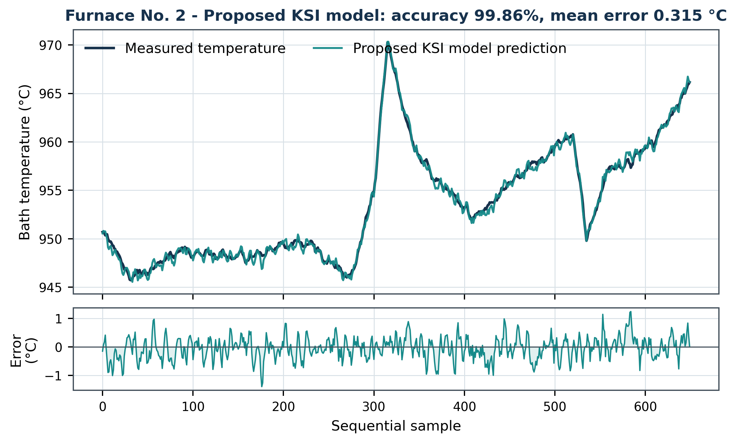
Figure 2. Proposed KSI model and measured temperature for aluminium electrolysis furnace No. 2 (schematic reconstruction).
In Figure 2, the accuracy of the model is 99.86% and the mean error between the model output and the real value is 0.315 °C. Figure 3 shows the output value of the fuzzy model obtained by ANFIS and the real output value in aluminium electrolysis furnace No. 2. The accuracy of the model of Figure 3 is 99.76% and the mean error between the output value and the real value is 2.289 °C.
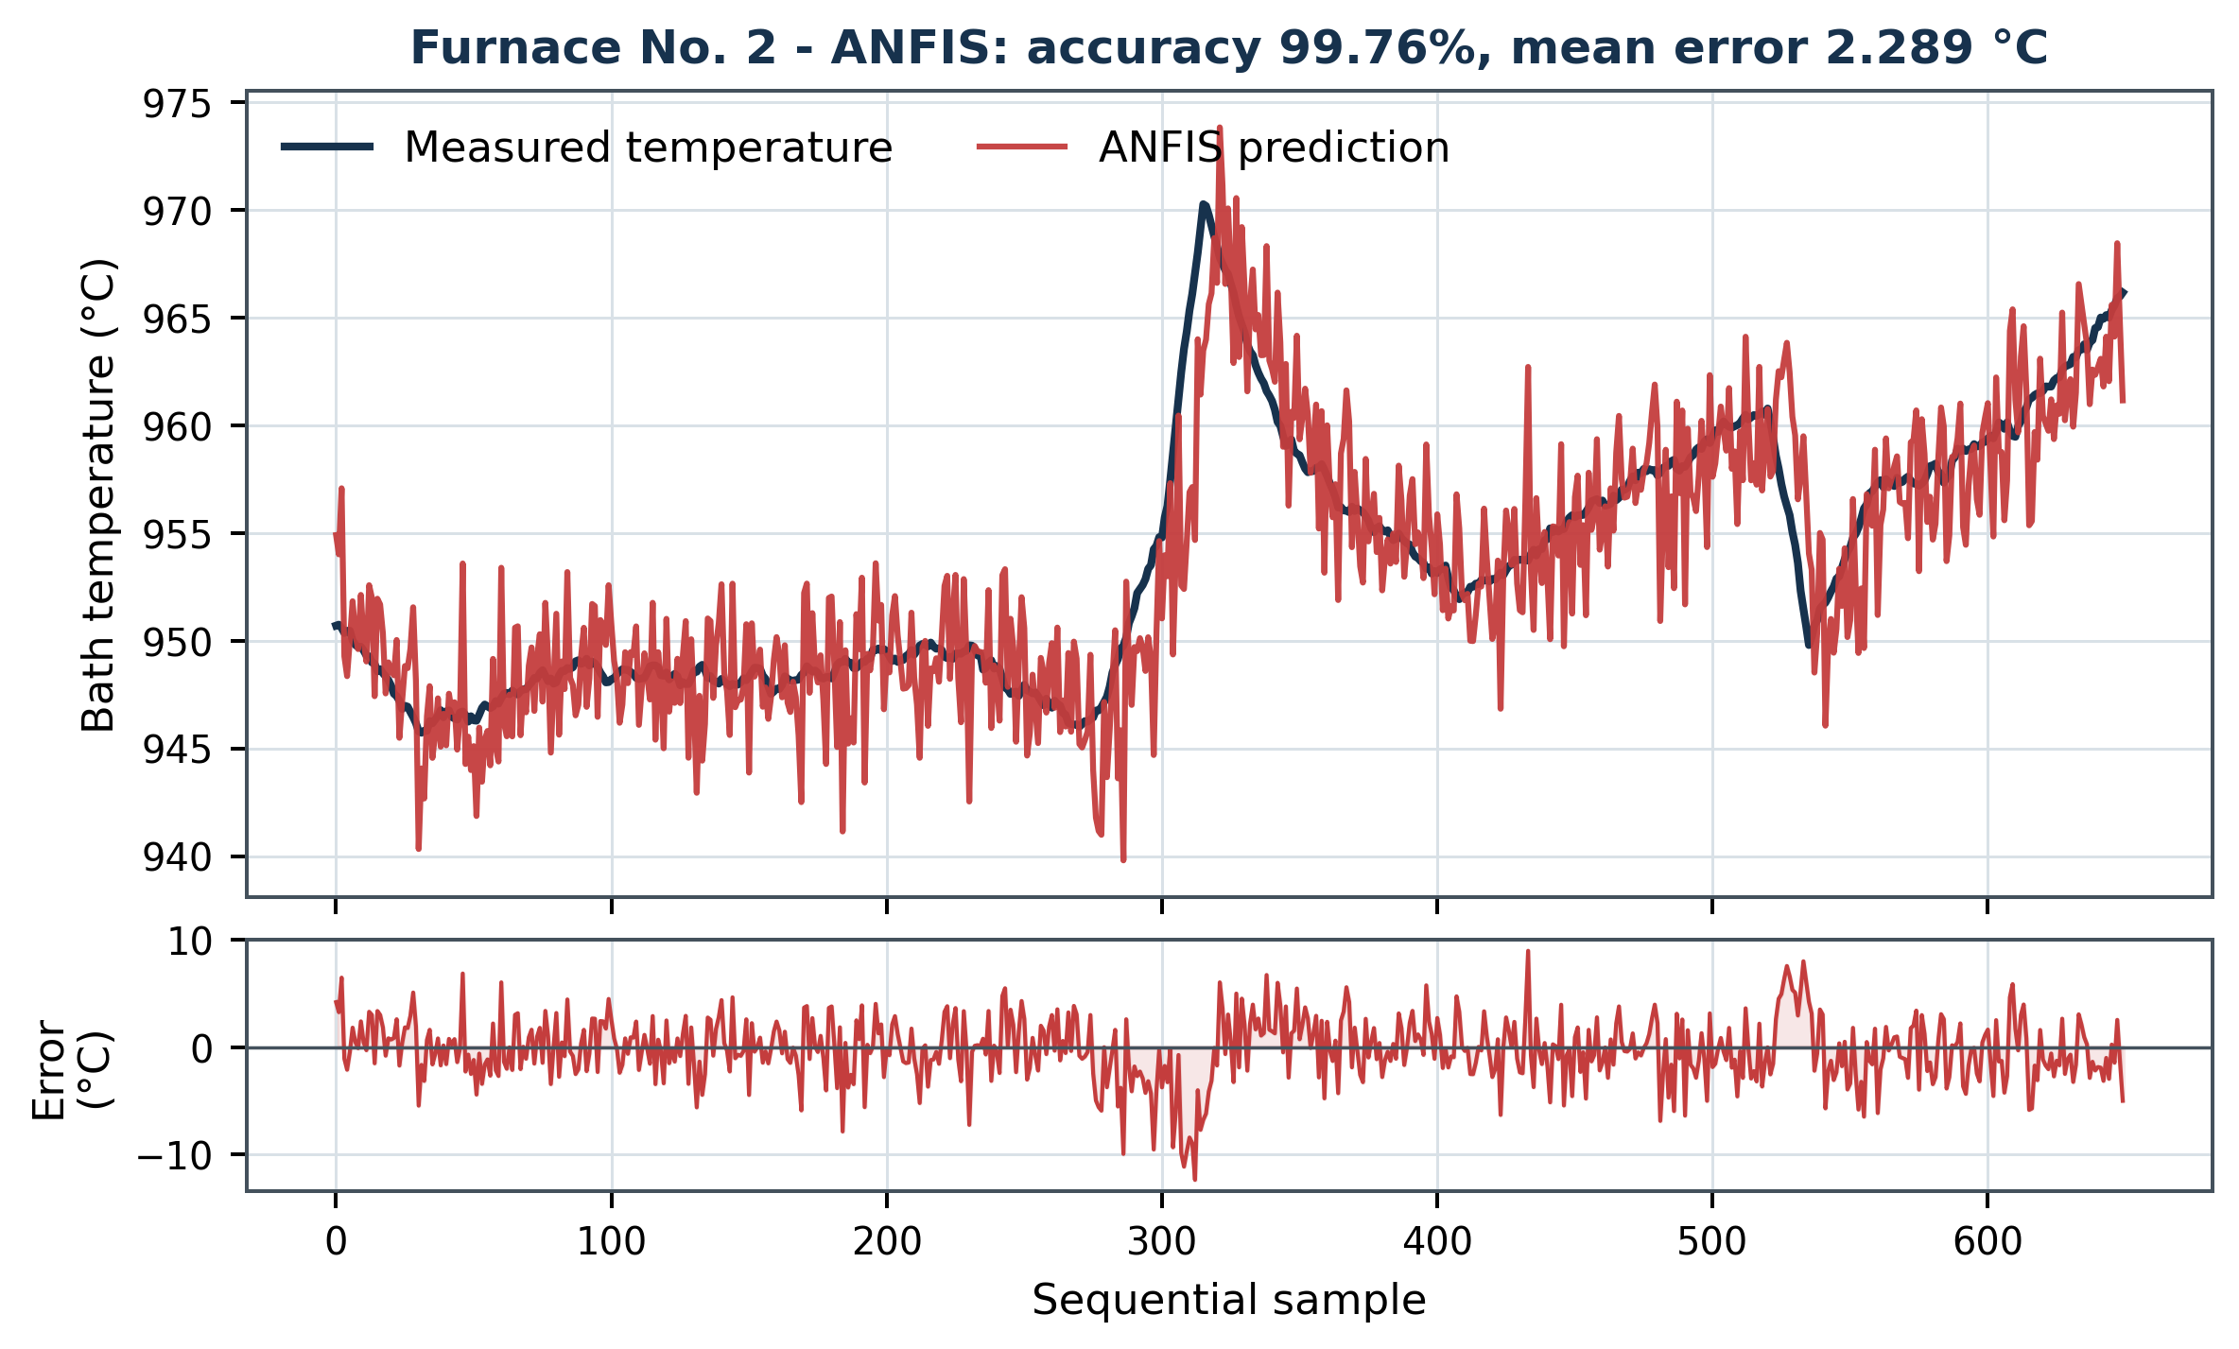
Figure 3. ANFIS model and measured temperature for aluminium electrolysis furnace No. 2 (schematic reconstruction).
The number of rules of the model obtained by ANFIS is 25, but by the proposed fuzzy modeling method it is only 5, and the mean error of our proposed method is two to three times smaller than that of ANFIS in the simulation experiment result, so we can conclude that applying the proposed method is very efficient. Table 1 shows the comparison of the experimental results that we obtained in the field with the previous result [8, 9] and the proposed method.

5 Discussion
Because the cited methods were evaluated on different cells, time periods, feature sets and error definitions, cross-paper numerical comparisons below are descriptive rather than statistical head-to-head tests. Direct numerical superiority is claimed only for methods evaluated on the same reported furnace data (proposed versus ANFIS for furnace No. 2, and proposed versus [8,9] in Table 1). For [14,15,18], the accessible source summaries do not provide an error metric directly commensurate with the 0.315 °C mean error used here; this is reported explicitly rather than replaced by an inferred value.
Table 1. Comparisons of [8, 9] and the proposed method.
No. | Aluminium electrolysis furnace | Method | Max deviation (°C) | Min deviation (°C) | Mean deviation (°C) | Model accuracy (%)
1 | No. 15 | Proposed | 4.6 | 0.1 | 1.57 | 99.84
1 | No. 15 | [8, 9] | 4.8 | 1.1 | 2.8 | 88.45
2 | No. 48 | Proposed | 6.2 | 0.8 | 2.94 | 99.71
2 | No. 48 | [8, 9] | 7.3 | 1.6 | 2.4 | 83.67
3 | No. 89 | Proposed | 11.1 | 0.4 | 6.05 | 99.40
3 | No. 89 | [8, 9] | 8.6 | 1.9 | 2.6 | 82.56
Table 1 demonstrates a clear gain in the manuscript's reported model-accuracy measure: the proposed model increases accuracy from 88.45% to 99.84% for furnace No. 15, from 83.67% to 99.71% for No. 48, and from 82.56% to 99.40% for No. 89. However, the deviation columns require a more careful interpretation than the earlier draft gave them. The proposed mean deviation is lower for No. 15 (1.57 °C versus 2.8 °C) but higher for No. 48 (2.94 °C versus 2.4 °C) and No. 89 (6.05 °C versus 2.6 °C). Therefore, the >99% 'model accuracy' metric is not equivalent to mean absolute deviation and should be defined mathematically in the final submission. The scientifically defensible conclusion is that the proposed method strongly improves the reported accuracy index across all three cells, while the error-distribution results are cell-dependent. This nuance is important and should be retained rather than claiming uniform improvement in every error statistic.
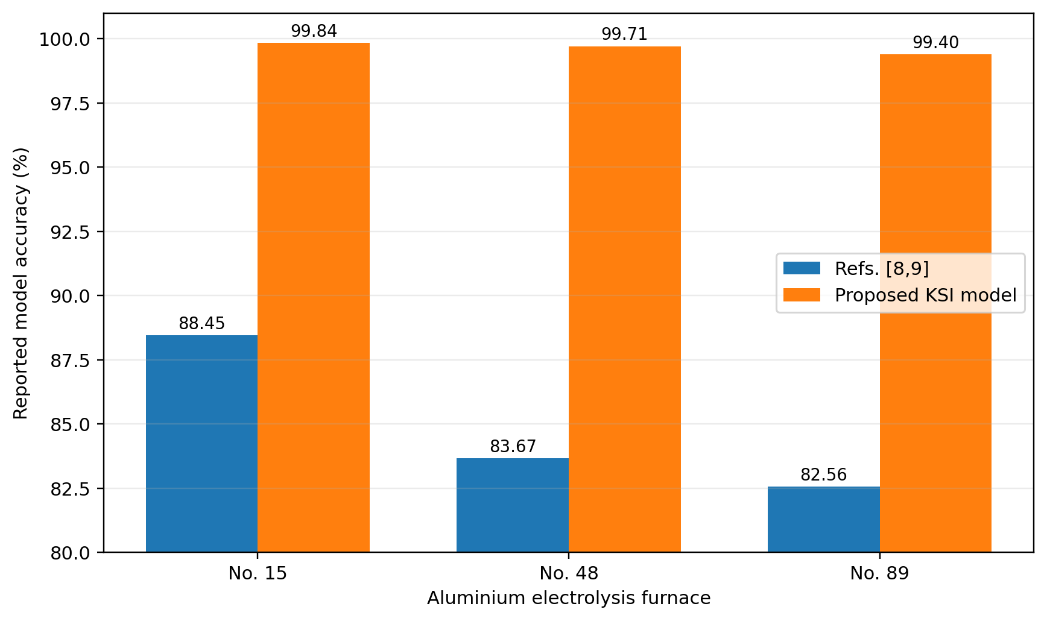
Figure 6. Field comparison of the reported model-accuracy measure for the proposed KSI model and references [8,9] on three aluminium electrolysis furnaces.
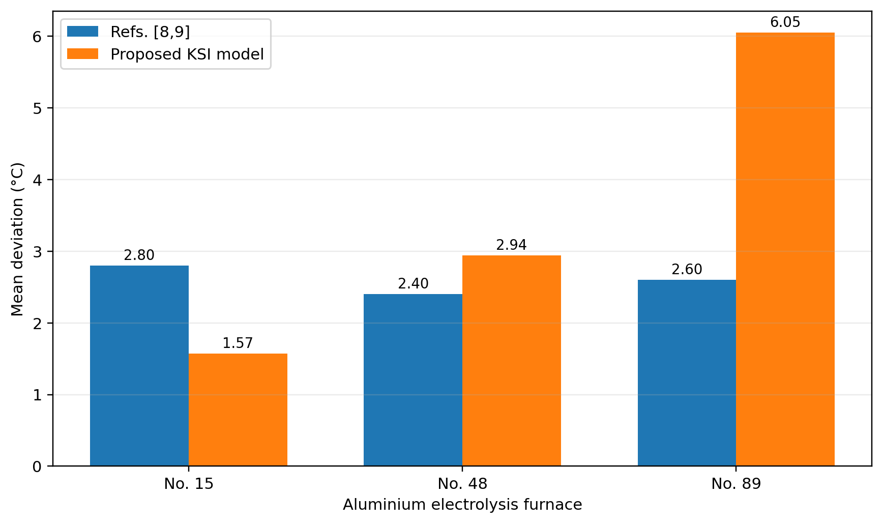
Figure 7. Field mean-deviation comparison. The proposed method reduces mean deviation on furnace No. 15 but not on Nos. 48 and 89, illustrating why accuracy and deviation metrics must be reported separately.
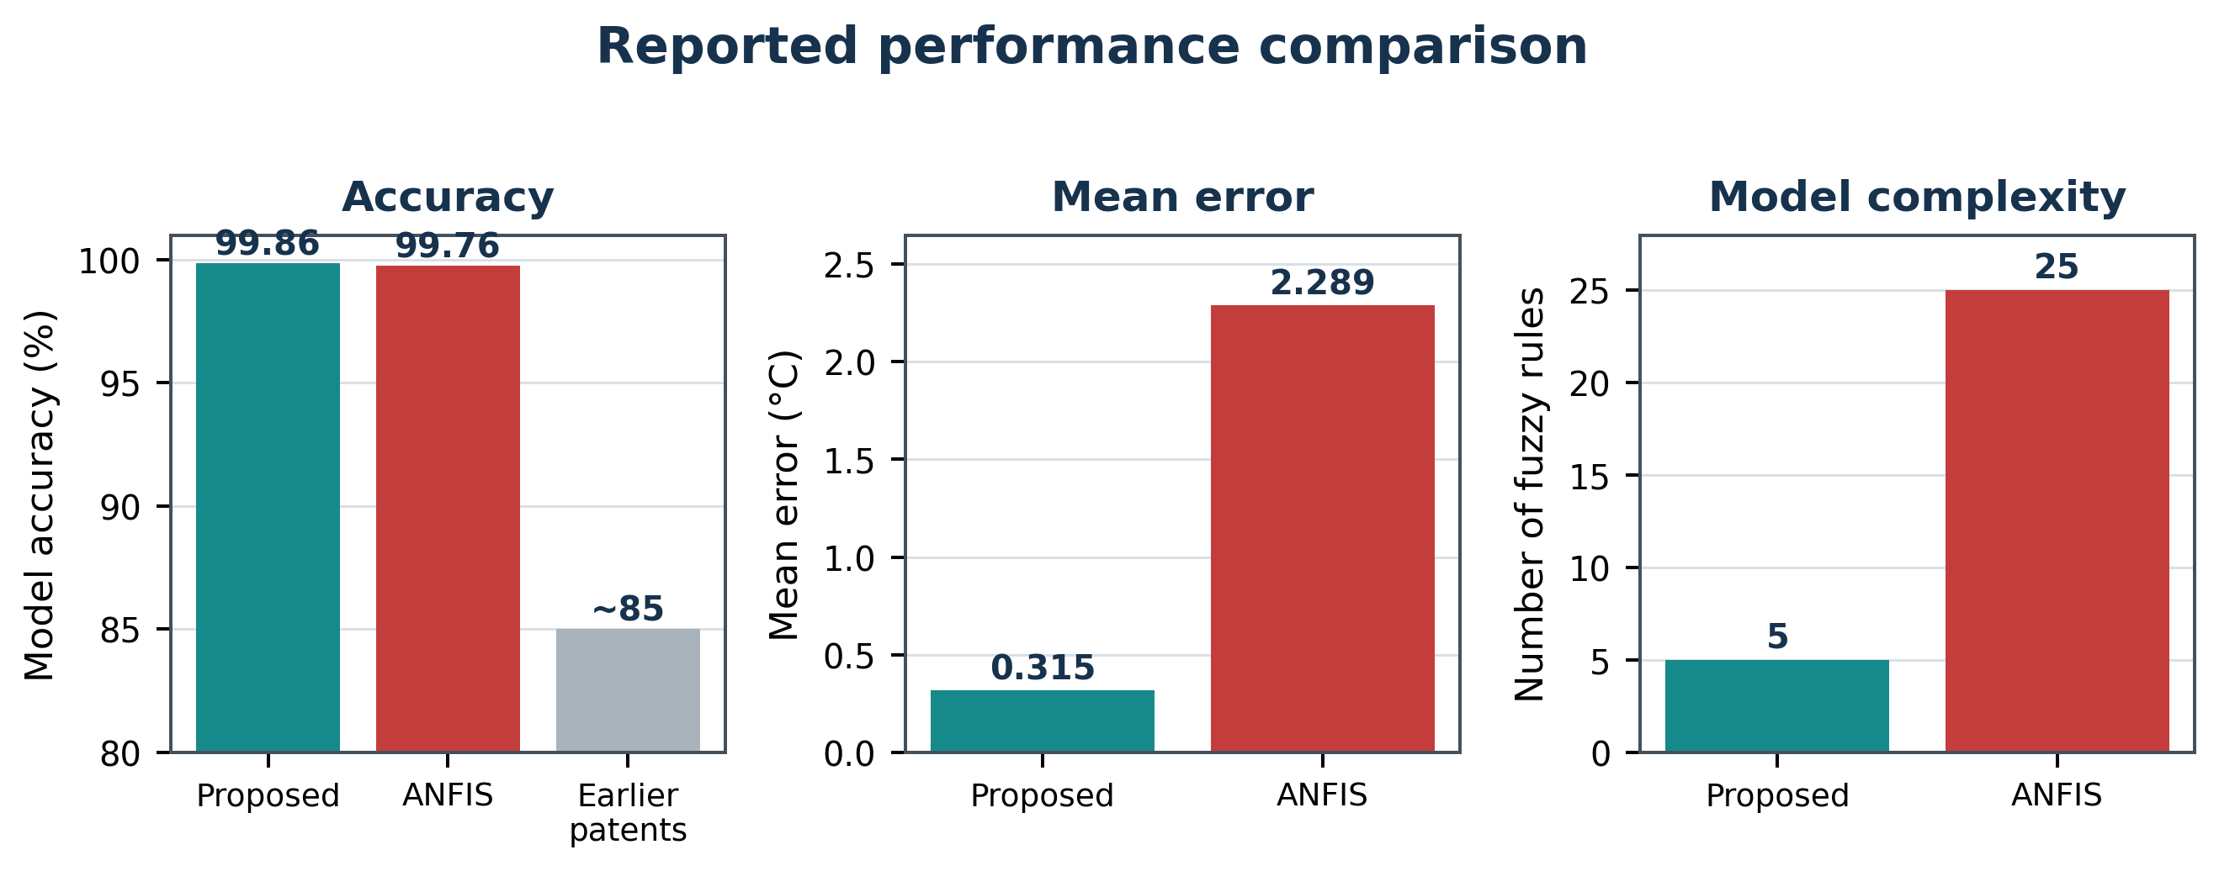
Figure 4. Reported accuracy, error, and rule-count comparison.

5.1 Detailed comparison with [17] and the KSI-principle context
Reference [17] is the strongest recent directly relevant machine-learning baseline in the literature reviewed here. It uses five supervised models (SVR, KRR, RF, GBDT and LightGBM) on historical production variables from a 500-kA reduction cell. LightGBM is best, and SHAP identifies the last bath temperature, fluoride-salt feeding weight, break/feed cycles, set voltage and metal-tapping weight as dominant features. Its average predicted-versus-measured temperature difference is 1.6 °C. In contrast, the proposed model uses a substantially narrower input channel (voltage/current plus dynamic lags) and sparse thermocouple labels, and its rule effect is generated by the KSI principle [26]. For furnace No. 2 the paper reports a mean error of 0.315 °C. These values cannot be treated as a controlled benchmark because the datasets and features differ, but the comparison is still informative: [17] emphasizes rich-data predictive accuracy with post-hoc SHAP interpretation, whereas the KSI model emphasizes low sensor/feature burden, direct rule-level interpretation and recursive online adaptation.
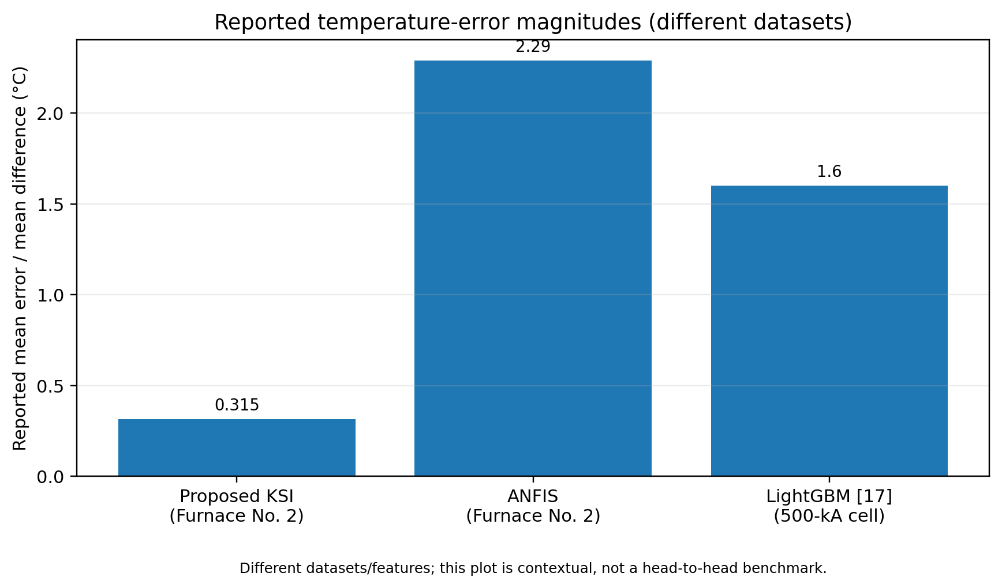
Figure 5. Contextual comparison of reported temperature-error magnitudes. The LightGBM value from [17] is from a different 500-kA-cell dataset and is therefore not a head-to-head benchmark.

5.2 Algorithmic and computational comparison with references [2,14,15,17,18]
Table 4 expands the discussion from prediction accuracy alone to algorithmic structure, computational amount, adaptation and interpretability. Complexity expressions are order-level descriptions based on the cited model classes; exact wall-clock times cannot be compared because the papers used different hardware and implementations. Let N be the number of training samples, E the number of offline epochs, h a recurrent hidden dimension, M the number of trees, D their depth, W the number of nonzero neural weights, R the number of fuzzy rules, d the regressor dimension, and P the number of T-S consequent parameters.
Table 4. Detailed comparison of the proposed model with references [2,14,15,17,18].
Method | Algorithm / modeling method | Training or online update | Order-level computational amount | Reported error / accuracy | Interpretability and main limitation
[2] Classical fuzzy modeling/control | Conventional fuzzy/T-S rules and interval updating | Model-dependent; manuscript reports interval measurement update | For RLS-T-S implementation: reasoning O(Rd), update O(P^2) | <91% accuracy as reported in this manuscript | High rule interpretability; baseline formulation here is less accurate and its cited recursive equation needs dimensional correction
[14] Self-supervised deep LSTM | Deep recurrent soft sensor with target-informed self-supervision | Offline iterative training; online forward inference | Training approx. O(E N h(h+d)); inference O(h(h+d)) per step | Paper reports improved accuracy/robustness; no directly commensurate °C metric available in source summary | Captures long memory; black-box hidden state, GPU/epoch burden
[15] DA-LSTM + ARMA | Wavelet decomposition + dual-attention LSTM + ARMA + regression fusion | Offline decomposition/training; fixed online inference | Wavelet O(N) + recurrent training O(E N h(h+d)) + ARMA | Effective in real aluminium process; metric not directly commensurate in accessible summary | Models mixed stationary/nonstationary dynamics but has the most complex pipeline
[17] LightGBM | Boosted decision-tree bath-temperature model + SHAP | Offline tree boosting; retrain when distribution changes | Training roughly O(M N log N); inference O(MD) | Average difference 1.6 °C | Strong accuracy and SHAP explanation, but rich feature set and offline retraining
[18] Sparse InputSkip NN | Sparse feedforward neural net with skip connections and L1 regularization | Offline gradient training | Training O(E N W); inference O(W) | Improves long-horizon accuracy/stability; no common °C metric in source summary | Good long-horizon stability with limited data; still data-trained neural model
Proposed KSI-T-S | KSI moving rates + normalized product reasoning + dynamic T-S | Single-pass RLS update only when measured T is available | Reasoning O(Rd); RLS O(P^2) per labeled update; no epochs | No.2: 99.86%, mean error 0.315 °C; field accuracy >99% | Five-rule traceable model, sparse labels; current study still needs standardized MAE/RMSE definition and common-dataset benchmark
The broader evidence supports a balanced interpretation. Against ANFIS on the same furnace No. 2 data, the proposed five-rule KSI model reports 0.315 °C mean error versus 2.289 °C for the 25-rule ANFIS model, an approximately 86.2% reduction in that reported error measure, while the reported accuracy changes from 99.76% to 99.86%. Relative to [17], the proposed value (0.315 °C) is numerically below the 1.6 °C average difference reported for LightGBM, but the studies use different cells and feature sets and therefore do not establish a statistically valid ranking. References [14,15,18] show that deep and sparse neural architectures can model long temporal dependencies and mixed-frequency dynamics, but they require offline training and have less direct rule-level interpretability. The KSI principle [26] provides the conceptual reason for the present model's different inference path: normalized rule influence is tied to moving/compensating relations rather than to a learned neural representation. Overall, the main empirical claim that is directly supported by same-data comparison is the compact five-rule advantage over the ANFIS baseline on furnace No. 2; the comparison with other papers should be read as a trade-space analysis of accuracy, computational burden, online adaptability and interpretability.

6 Conclusion
This paper presented a KSI-principle real-time temperature soft sensor for aluminium electrolysis cells by embedding moving-rate reasoning into a dynamic Takagi-Sugeno model. The revised formulation makes the algorithmic contribution explicit: moving rates are evaluated for s-, z-, and trapezoidal antecedents; KSI product reasoning generates normalized rule effects; those effects construct the T-S regression vector; and recursive least squares updates the consequent parameters only when a new measured temperature becomes available. This gives an interpretable online path with O(Rd) reasoning work and O(P^2) RLS work per labeled update, avoiding multi-epoch retraining. The analysis also clarifies that the correction made to the earlier recursive formula is a correction to a particular baseline estimation expression rather than a rejection of the general Takagi-Sugeno framework.
The experimental evidence should be interpreted with metric discipline. On furnace No. 2, the proposed five-rule model reports 99.86% accuracy and 0.315 °C mean error, compared with 99.76% and 2.289 °C for the 25-rule ANFIS baseline. Across the three field furnaces in Table 1, the proposed method raises the reported accuracy index above 99%, although mean deviation is not uniformly smaller on every furnace. The comparison with LightGBM [17], deep LSTM [14], DA-LSTM/ARMA [15], sparse neural identification [18], and recent ANFIS methods [31-35] shows that the principal advantage of the KSI model is not merely a single error number but the combination of compact rule structure, sparse-sensor operation, online recursive adaptation and direct inference traceability. Future work should use a common rolling-origin dataset and standardized MAE, RMSE, MAPE and timing metrics so that statistical significance, computational latency and cross-cell transfer can be evaluated fairly.
In future work, we will extend the proposed method to interval and type-2 fuzzy models following the interval extension of the KSI principle [26], combine it with metaheuristic parameter scheduling such as improved shark smell optimization [30] for automatic tuning of the membership breakpoints, and integrate the prediction model into model-predictive temperature control of the potline.

Reproducibility and reporting note
The pseudocode in Sections 3 and 4 defines all computational steps needed to reproduce the proposed reasoning and online-update logic. For a journal submission, the authors should additionally provide the exact membership breakpoints, lag orders, forgetting factor, initial covariance, the mathematical definition of the reported 'model accuracy' percentage, and de-identified sample data or a synthetic benchmark. These items are necessary for independent reproduction and for a statistically controlled comparison with [14,15,17,18,31-35].

References
- Zadeh, L. A.: The concept of a linguistic variable and its applications to approximate reasoning, I, II, III. Information Sciences 8, pp. 199-249, 301-357; 9, pp. 43-80, 1975.
- Zhang, H., et al.: Fuzzy Modeling and Fuzzy Control, pp. 33-62, 2009.
- Moazamigoodarzi, H., Pal, S., Ghosh, S., Puri, I. K.: Real-time temperature predictions in IT server enclosures. International Journal of Heat and Mass Transfer 127, pp. 890-900, 2018.
- Fu, Z., Yu, X., Shang, H., Weng, Z., Zhang, Z.: A new modeling method for superalloy heating in resistance electrolysis furnace using FLUENT. International Journal of Heat and Mass Transfer 128, pp. 679-687, 2019.
- Kwak, S.-I., et al.: A fuzzy reasoning method based on compensating operation and its application to fuzzy systems. Iranian Journal of Fuzzy Systems 16(3), pp. 17-34, 2019. DOI: 10.22111/IJFS.2018.4175.
- Kwak, S.-I., Kim, U.-H., Kim, K.-J., Son, I.-M.: Fuzzy reasoning method based on distance measure and its reductive property. WSEAS Transactions on Computer Research 8, pp. 73-89, 2020. DOI: 10.37394/232018.2020.8.10.
- Kwak, C.-J., Ri, K.-C., Kwak, S.-I., Kim, K.-J., Ryu, U.-S., Kwon, O.-C., Kim, N.-H.: Fuzzy modus ponens and tollens based on moving distance in SISO fuzzy system. Romanian Journal of Information Science and Technology 24(3), pp. 257-283, 2021.
- Li, J.: Fault predictor for aluminium electrolysis. Chinese Invention Patent Publication Specification, pp. 1-8, 2006 (in Chinese).
- Luo, Y.: On-site measuring device for the primary-crystal (liquidus) temperature of aluminium electrolyte. Chinese Utility Model Patent Specification, pp. 1-12, 2010 (in Chinese).
- Zhou, K., Zhang, Z., Liu, J., Hu, Z., Duan, X., Xu, Q.: Anode effect prediction based on a singular value thresholding and extreme gradient boosting approach. Measurement Science and Technology 30(1), pp. 1-11, 2019. DOI: 10.1088/1361-6501/aaee5e.
- Lu, H., Hu, X., Cao, B., Chai, W., Yan, F.: Prediction of liquidus temperature for complex electrolyte systems Na3AlF6-AlF3-CaF2-MgF2-Al2O3-KF-LiF based on machine-learning methods. Chemometrics and Intelligent Laboratory Systems, pp. 110-120, 2019. DOI: 10.1016/j.chemolab.2019.03.015.
- Cao, B., Cui, J., Li, Q., Wang, M., Li, X., Yan, Q.: Online prediction method of molten aluminium height in electrolytic cell based on extreme learning machine with kernel function. Mathematical Problems in Engineering 2021, 9980194, 2021. DOI: 10.1155/2021/9980194.
- Chen, L., Wu, Y., Liu, Y., Liu, T., Sheng, X.: Time-series prediction of iron and silicon content in aluminium electrolysis based on machine learning. IEEE Access 9, pp. 10699-10710, 2021. DOI: 10.1109/ACCESS.2021.3050548.
- Lei, Y., Karimi, H. R., Chen, X.: A novel self-supervised deep LSTM network for industrial temperature prediction in aluminum processes application. Neurocomputing 502, pp. 177-185, 2022. DOI: 10.1016/j.neucom.2022.06.080.
- Zhu, X., et al.: Temperature prediction of aluminum reduction cell based on integration of dual attention LSTM for non-stationary sub-sequence and ARMA for stationary sub-sequences. Control Engineering Practice, 2023.
- Li, X., Lin, J., Liu, C., Liu, A., Shi, Z., Wang, Z., Jiang, S., Wang, G., Liu, F.: Research on aluminum electrolysis from 1970 to 2023: a bibliometric analysis. JOM 76(7), pp. 3265-3274, 2024. DOI: 10.1007/s11837-024-06596-1.
- Lin, J., Liu, A., Wang, Z., Shi, Z., Liu, F.: Bath temperature prediction of aluminum reduction cell based on machine learning algorithm. Journal of Sustainable Metallurgy 11, pp. 1419-1430, 2025. DOI: 10.1007/s40831-025-01027-0.
- Lundby, E. T. B., et al.: Sparse neural networks with skip-connections for modeling the mass and energy balance of aluminum electrolysis cells, 2023.
- Luo, M., Wang, Y.: Interval-valued fuzzy reasoning full implication algorithms based on the t-representable t-norm. International Journal of Approximate Reasoning 122, pp. 1-8, 2020. DOI: 10.1016/j.ijar.2020.03.009.
- Li, F., Shang, C., Li, Y., Shen, Q.: Interpretable mammographic mass classification with fuzzy interpolative reasoning. Knowledge-Based Systems 191, 105279, 2020. DOI: 10.1016/j.knosys.2019.105279.
- Duan, J., Li, X.: Similarity of intuitionistic fuzzy sets and its applications. International Journal of Approximate Reasoning 137, pp. 166-180, 2021.
- Liu, Z., Li, X.: Quintuple intuitionistic fuzzy implications reasoning algorithms and application. Iranian Journal of Fuzzy Systems 20(1), pp. 153-170, 2023.
- Xu, R., Lin, J., Shang, C., Shen, Q.: Towards dynamic fuzzy rule interpolation via density-based spatial clustering of interpolated outcomes. Proceedings of the IEEE International Conference on Fuzzy Systems (FUZZ-IEEE), 2023.
- Son, I. M., Kwak, S. I., Han, U. J., Pak, J. H., Han, M., Pyon, J. R., Ryu, U. S.: A novel fuzzy approximate reasoning method based on extended distance measure in SISO fuzzy system. arXiv:2003.13450, 2020.
- Kwak, S.-I., et al.: New approximate reasoning method based on least common multiple and its property analysis. Proceedings of the 5th International Conference on Applied Science, Engineering and Management, 2022.
- Kong, H.-U., Kwak, S.-I., Jang, Y.-J., Hwang, C.-J., Ri, O.-S., Jo, Y.-H., Nam, J.-H., Ryu, U.-S.: New interval fuzzy modeling method based on KSI principle and its application in turf color image evaluation. Journal of Industrial and Management Optimization 21(12), pp. 6713-6735, 2025. DOI: 10.3934/jimo.2025146.
- Kim, U.-H., Kwak, S.-I., Jang, U.-J.: Investigation and selection of growth parameters of rice using FCM algorithm. Information Technologies: Problems and Solutions, 2025.
- Kim, I.-G., Kwak, S.-I.: Implementation and result analysis of precipitation forecast and disaster warning system. Information Technologies: Problems and Solutions, 2025.
- Choe, J.-H., Jang, Y.-J., Kwak, S.-I., Ri, O.-S., Kong, H.-U.: Causal-entropic fuzzy inference: a Bayesian framework for explainable and robust fuzzy reasoning. Journal of Fuzzy Systems and Control 4(1), 2026. ISSN 2986-6537. DOI: 10.59247/jfsc.v4i1.392.
- Choe, J.-H., Choe, G.-C., Kwak, S.-I., Chae, H.-G., Kong, H.-U.: Improved shark smell optimization with adaptive parameter scheduling for fuzzy controller tuning. Academy Journal of Science and Engineering 20(1), 2026.
31. Feced-Mas, V., Mota-Babiloni, A., Navarro-Esbri, J., Udroiu, C.-M.: Novel adaptive neuro-fuzzy inference system (ANFIS) based approach for robust, precise and transparent temperature control in thermal systems guided by explicit design framework. Energy Conversion and Management 366, 121810, 2026. DOI: 10.1016/j.enconman.2026.121810.
32. Donkor, D. N., Ogudo, K. A., Rameshar, V.: Hybrid Mamdani-ANFIS Data-Driven Control on an Industrial Heating Furnace. Automation 7(3), 84, 2026. DOI: 10.3390/automation7030084.
33. Azma, A., Liu, Y.: Enhancing CFD computational efficiency using hybrid data-driven and physics-based modeling. Case Studies in Thermal Engineering 78, 107641, 2026. DOI: 10.1016/j.csite.2026.107641.
34. Khasawneh, M. A., Mewada, H., Khasawneh, A. A., Sawalha, A. A.: Thermal features prediction in asphalt pavements using ANFIS-based regression. Discover Civil Engineering 2, 97, 2025. DOI: 10.1007/s44290-025-00257-1.
35. Nik-Khorasani, A., Sadoghi-Yazdi, H., Mehrizi, A.: Robust hybrid learning approach for adaptive neuro-fuzzy inference systems. Fuzzy Sets and Systems 481, 108890, 2024. DOI: 10.1016/j.fss.2024.108890.
36. Chen, C., Ran, L., Zeng, Z., Li, J., Cao, X., Wang, Y., Han, B., Zhang, H.: Rapid Prediction of Side Ledge Morphology and Thermal Fields in Aluminum Reduction Cells via CFD-Based Machine Learning. Metals 16(8), 890, 2026. DOI: 10.3390/met16080890.
37. Novozhilov, I. M., Ilyushina, A. N., Martirosyan, K. V.: Coupled Electro-Thermal Modeling of the Temperature Field in an Aluminum Reduction Cell Using the Finite Difference Method. Processes 14(8), 1284, 2026. DOI: 10.3390/pr14081284.
38. Betsis, K., Karkalos, N. E., Xenidis, A.: Comparison of machine-learning models in predicting the liquidus temperature of aluminum cryolitic bath. Materials Chemistry and Physics 340, 130865, 2025. DOI: 10.1016/j.matchemphys.2025.130865.
39. Li, Q., Huang, G., Cui, J., Wang, M., et al.: A temperature field prediction method for aluminum electrolysis cell based on improved CNN-LSTM. 2025 IEEE 14th Data Driven Control and Learning Systems Conference (DDCLS), 2025. DOI: 10.1109/DDCLS66240.2025.11066020.
40. Kumar, P., Katyayn, A., Jain, A., Sharda, A., Paswan, S. K., Kashav, R.: Evaluating the performance of the adaptive neuro-fuzzy inference system (ANFIS) in predicting reheat gas turbine cycle output using machine learning techniques. International Journal of Engine Research, OnlineFirst, 2026. DOI: 10.1177/14680874261444265.

